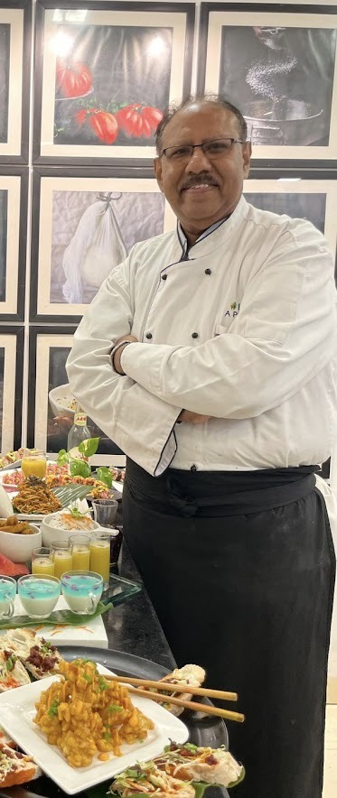
Avinash Rajput
Date of birth:17/06/1963
Hospitality Leader - Hotel Opening Expert
30+ Years in U.K. & Global Markets – F&B Operations Specialist
Lifetime Achievement National Award for Excellence in World Congress 2025
Professional Experience - Consultancy Services
University of Mumbai

August 2015 till date

Founded Just Appetite Culinary School and Education Academy in India
in 2015 to grow the International F & B Growth In the World

Hospitality related Projects ( Hotels, Restaurants, Lounges, Pubs ) in Dubai,
Britain, Switzerland, India and Oman
Recruiting skilled Hotel Staff for Europe, Dubai and India

Professional Experience
November 2012 – August 2018

● Education Projects in India and
● Projects in Dubai

Designation
Got UK investments in India
Professional Experience August 2010 -
November 2012

Executive Director of Operations & Projects in Hotels
Project Planning & Development. Vendor Sourcing &
Negotiating
P&L Management ;Risk Management
Customer Relations & Satisfaction ;Labor, Marketing Cost
Controls
Inventory Control ;Human Resources Management
Sales, Product, Market Analysis;Facility Management
Team Building & Staff Retention ;Think ‘out-of-the-box’ (be
creative, innovative)
Specialties Opening Hotels from Project Stage to
Operations ,Branding the Hotels with International Brands
Setting Up complete Operations

Professional Experience
May 2008 to August 2010

Group Director of Operations & Projects
Beverley Tower Hotels.London.UK
Handling Projects on Expansion for the Group in UK
● Express By Holiday Inn Leicester .UK (110rooms + Conference
Facilities & Restaurant+ Bar Banqueting Facilities
● Express By Holiday Inn, Victoria, London (110 rooms + Conference
Facilities)
● Planned & Opened successfully “KAZKAZINI” Fine dining Pub and
restaurant
adjacent to the hotel with 120 covers and 200 covers banqueting facilities.

Professional Experience
2002 – 2008

Group Director Hotels & Project coordination
Splendid Hotel Group .UK & Dubai (IHG Franchisee
Hotels)
Was handling F&B operations and Central Purchases
For 15 Hotels for the Group in UK & 02 Hotels in Dubai.
Worked with Hotel Brands Listed Below :
• Holiday Inn ,Express By Holiday Inn , Best Western,
Comfort Inns, Easy Hotels)
2004 – Opened
● Holiday Inn Camden Lock, London
134rooms + 2 F&B outlets and Banqueting facilities
2005 – Opened :
● Holiday Inn Brentford Lock ,London
130 rooms with 2 F&B outlets & Grand Ball Room
● Express By Holiday Inn ,Earls Court .London
110 rooms with Conference Facilities
2006 - Opened
● Holiday Inn Manchester West .Manchester
84 rooms + 2 F&B outlets + Conference facilities
● Astor Hotel,Victoria,London - 40rooms + F&B Facilities
● Easy Hotel ,Victoria ,London- 80rooms
● Re launched Express By Holiday Inn Royal Docks
,Canning Town, London with additional 40 rooms
2007 – 2008 – Splendid Investments Dubai
Projects handled and completed in Dubai
2008 – Opened
● Splendid Hotel Apartments 110 rooms + 3 F&B Outlets ,
Five Star Deluxe , Apartment Hotel ,Dubai
● Holiday Inn ,Al Barsha ,Dubai
Five Star Deluxe Property , 310 rooms with 10 F&B outlets
and Conference Facilities
(Launched the New Hall Mark of Holiday Inn In UAE)
Corporate Head and Food Court Advisor with the
Group.
Pashmina Restaurants Ltd .UK
● Operating three restaurants and the Central Production Unit in UK
● Developed the Selfridges and Harrods retail food courts
● Planned a chain of Fine dining restaurants called Pashmina
● Production of the “Asian Meals” Tesco. ASDA,
● Harrods,
● Selfridges, Hospital Meals,
● Tiffin bites, Jashan Restaurants at UK & Dubai

Professional Experience
1989 – 2002

Executive Chef / Executive Sous Chef
The Leela Hotels & Resorts ( Kempinski Hotels & Resorts )
Planning & Executing the Kitchen Projects and F&B Service outlets for the Group.
Opening of
● The Leela Kempinski
Mumbai Five Star Deluxe Property – 423 rooms – 10 F&B Outlets ,
● The Leela Goa – Five Star Deluxe Property - 120 villa- 8 F&B
Outlets
● Planning & Executing The Leela Bangalore Kitchens
Planned and commissioned the :
● Coffee Shop called Citrus. @ The Leela Mumbai & Bangalore
● Indian Fine Dining Restaurant – Jamavar. @ The Leela Goa and
Bangalore
● Redesigning of the Main Kitchens and Bakery Confectionery @ The
Leela Kempinski Mumbai
1995 - Cyprus - Indian Food Festival @ Hilton received
● President Award given by his Highness President Mr. Glafkos Clerides
at Hilton Hotel Nicosia, Cyprus

Oberoi Hotels, India.
1993 ......Sous Chef / Kitchen Executive
Opened the Five Star Deluxe Hotel – 150 Rooms and 04 F&B Outlets
At Agra “The Trident, Agra”, The first Hotel with “Novotel” French
Group”. Opportunity to get trained under Novotel Management.
Accomplished the task successfully.
1990
The Oberoi Towers and The Oberoi ;
1100 Rooms and 20 F&B Outlets Mumbai .India
Sous Chef Tournant / Kitchen Executive given to work at :
● Rotisserie – Fine Dining French Restaurant – 80 Covers ,Café Royal –
Fine Dining French Restaurant – 80 Covers , Mewar – Indian Fine
Dining Restaurant 100 covers ;Khandar – Fine Dining Indian Restaurant
– 80 Covers
Chef In charge to co-ordinate and refurbish the busiest; Coffee Shop
● “Samarkand” – now – “Palms” – opened Palms after renovation along
with Kitchen Facility Planning,
Selected to Plan and Commission –
● “Casa Mexicana” – Mexican Restaurant” Fine Dining Mexican
Restaurant @ The Oberoi, Mumbai.
1989 ......The Babylon Oberoi –
5 Star Deluxe, 210 rooms with 08 F&B Outlets, Baghdad, Iraq.
Sous Chef -Sky Chateau - French Restaurant 110 Covers, Fine Dining
Restaurant .in the City of Baghdad. Iraq. Was fully responsible for Catering to all
VIP delegates, His Highness Mr.Sadam Hussain, Mr. Yasser Arafat.

Professional & Training Experience
1985 – 1988

1988...... The Meena House Oberoi –
5 Star Deluxe Hotel with 10 F&B Outlets .Cairo ,Egypt
As Chef de Partie ;French Fine Dining Restaurant ; 110 Covers ,
Fully Responsible as a Chef for – His Highness President of Egypt Mr.Husani
Mubarak.

1985........ Taj Inter Continental ,Mumbai India
Five Star Deluxe Hotel 680 rooms with 13 F&B Outlets ,Mumbai .India
as Kitchen Trainee

Educational & Professional
Qualifications

BA;HMCT ;
MIHM(UK) ;MCGC(London);BII (UK)

Passport Detaiils:

UK Passport No :524433797 Date of issue : 27th June 2014
Nationality :British

Permanent Address :
C/120, Marwah Road , Andheri East .Mumbai 400 072 .India

